**What is MongoDB?**

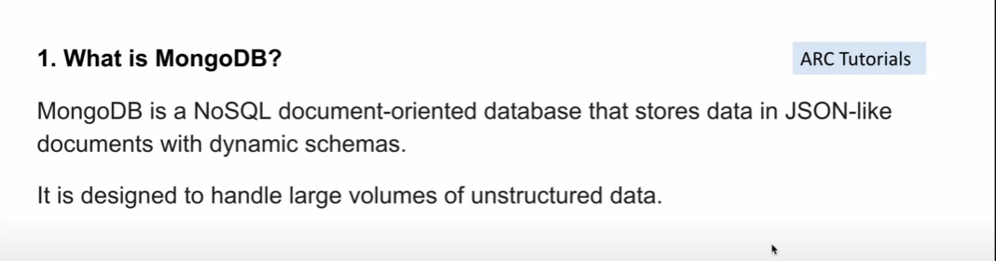

**What is a document in MongoDB?**

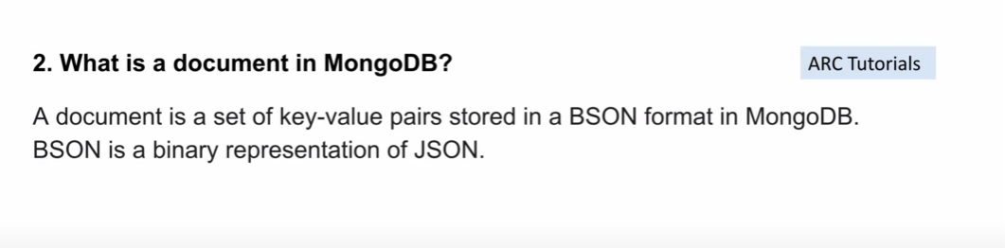

**BSON vs JSON**

BSON is a binary-encoded format, whereas JSON is a text-based format.

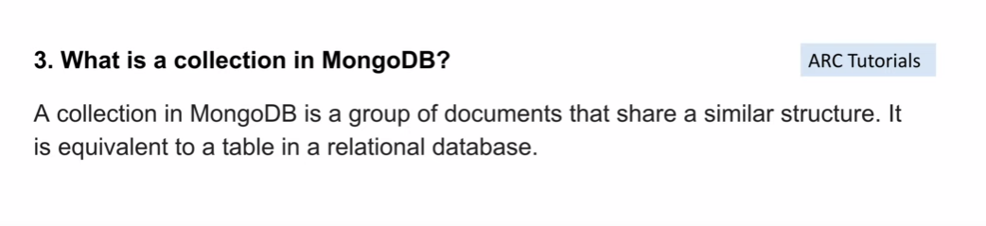

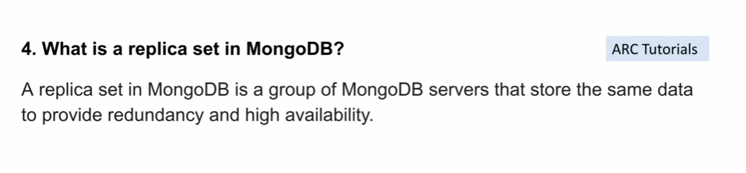

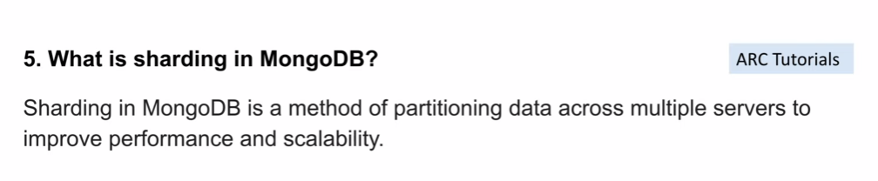

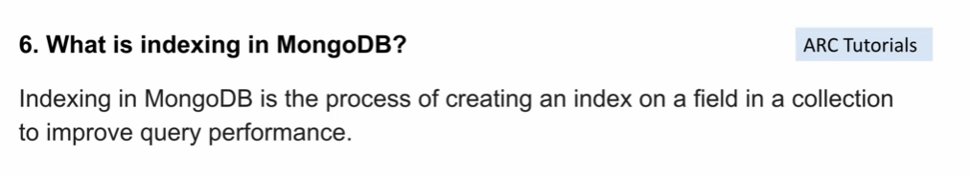

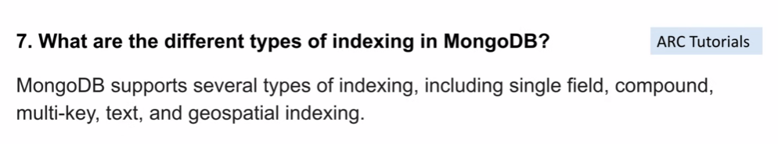

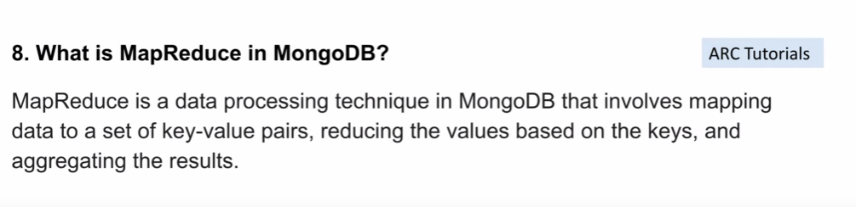

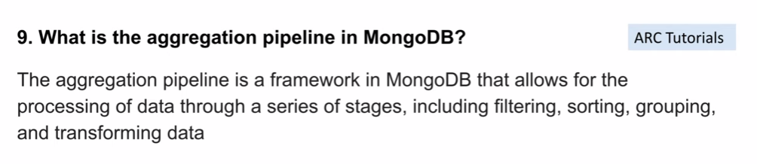

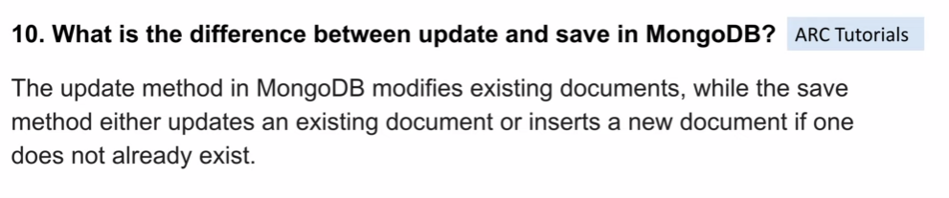

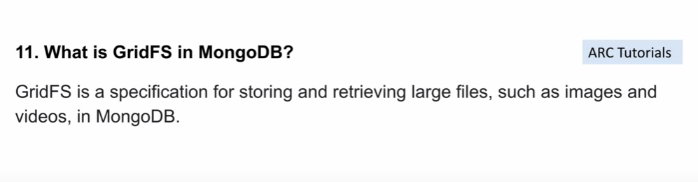

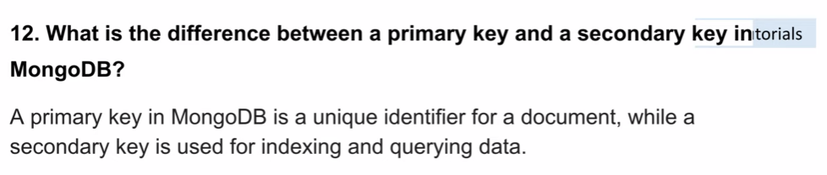

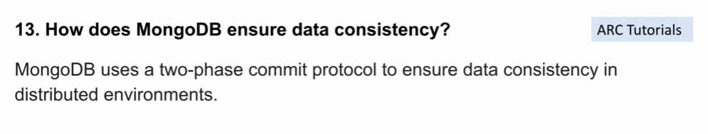

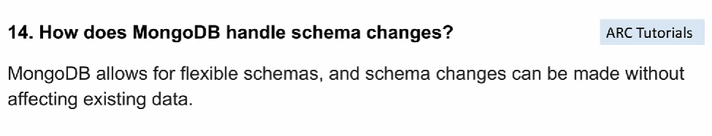

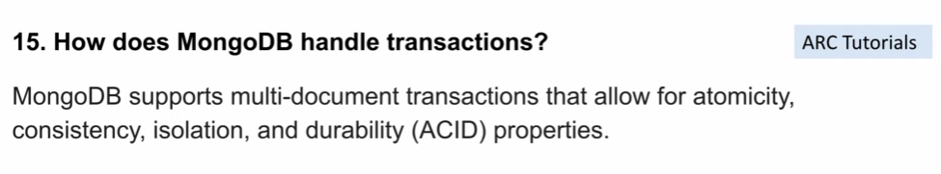

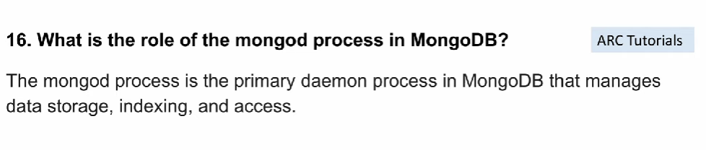

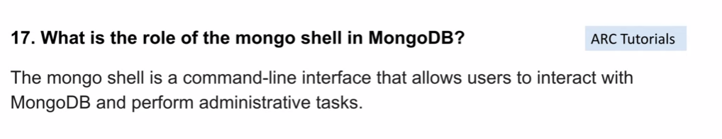

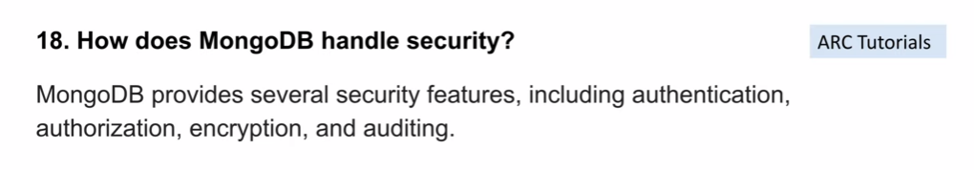

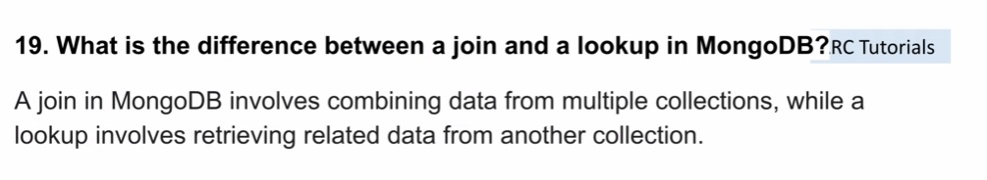

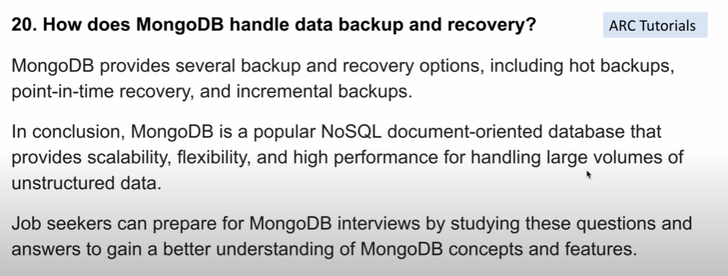

**What is the difference between update and findOneAndUpdate?**

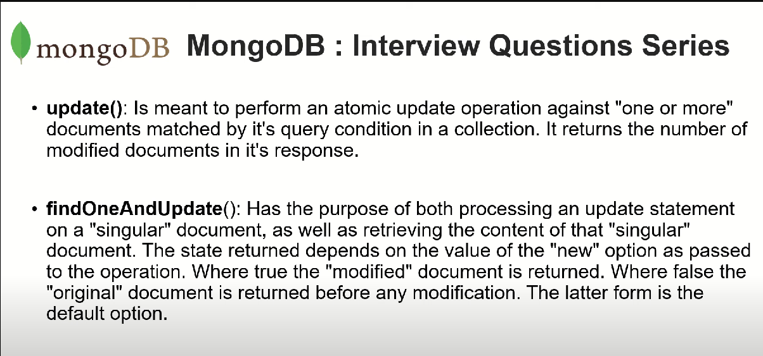

**What is the difference between drop and remove?**

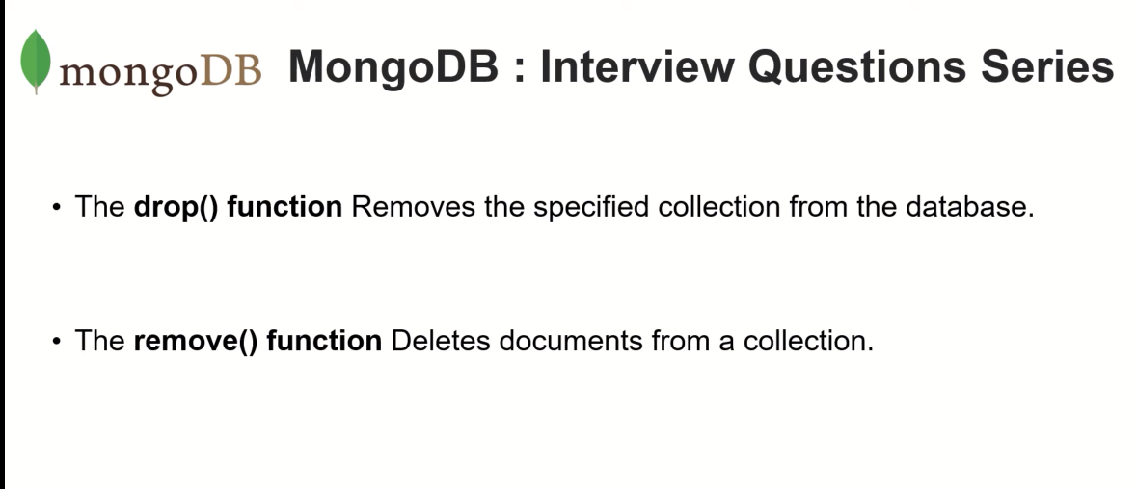

**What is difference createIndex and reindex?**

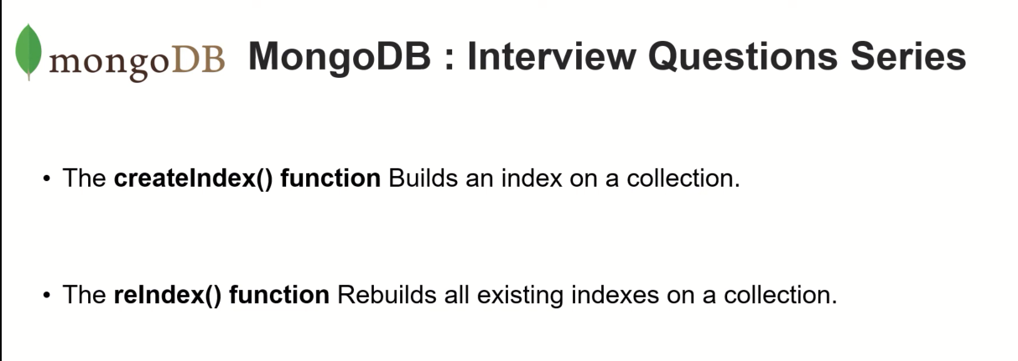

**How to get system info on which MongoDB is running?**

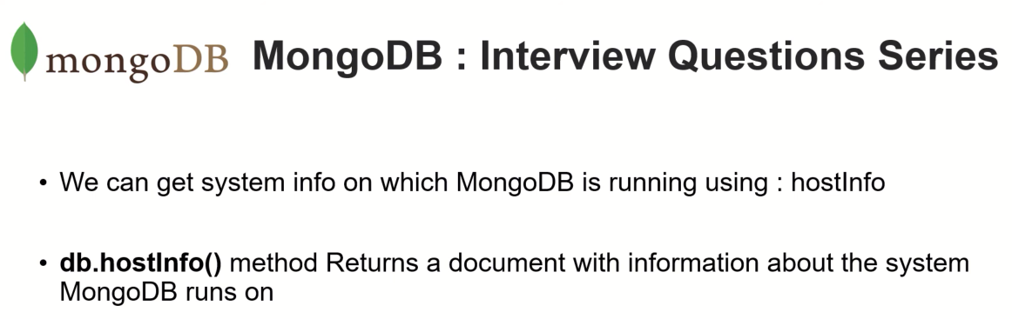

**How to remove the current database?**

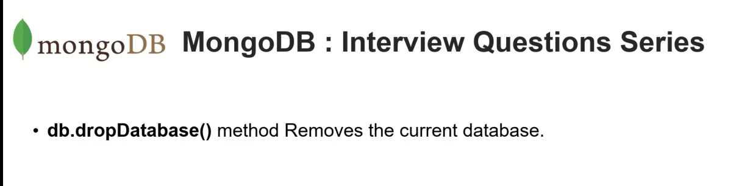

**How to rename a collection?**

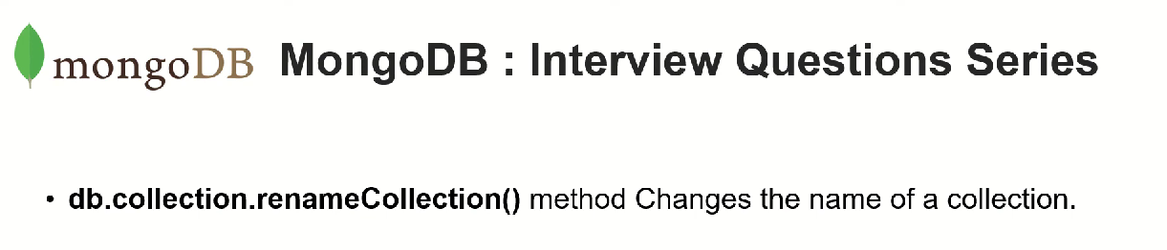

**What is the difference between findModify() and findOneAndUpdate()?**

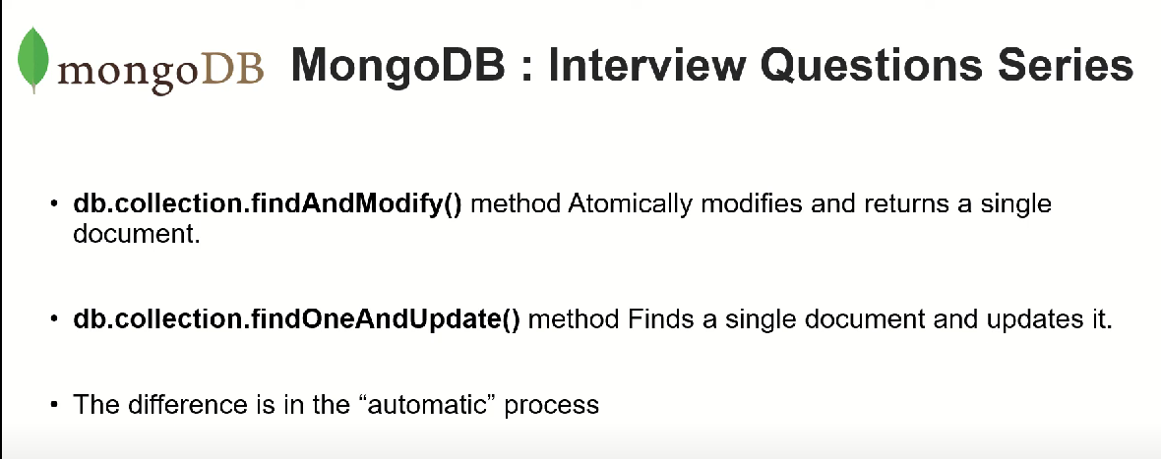

**updateone vs replaceone mongodb**

With replaceOne() you can only replace the entire document, while updateOne() allows for updating fields.

**Group By**

db.products.aggregate([{$group:{_id:'$type',count:{$sum:1}}}])